Press Release
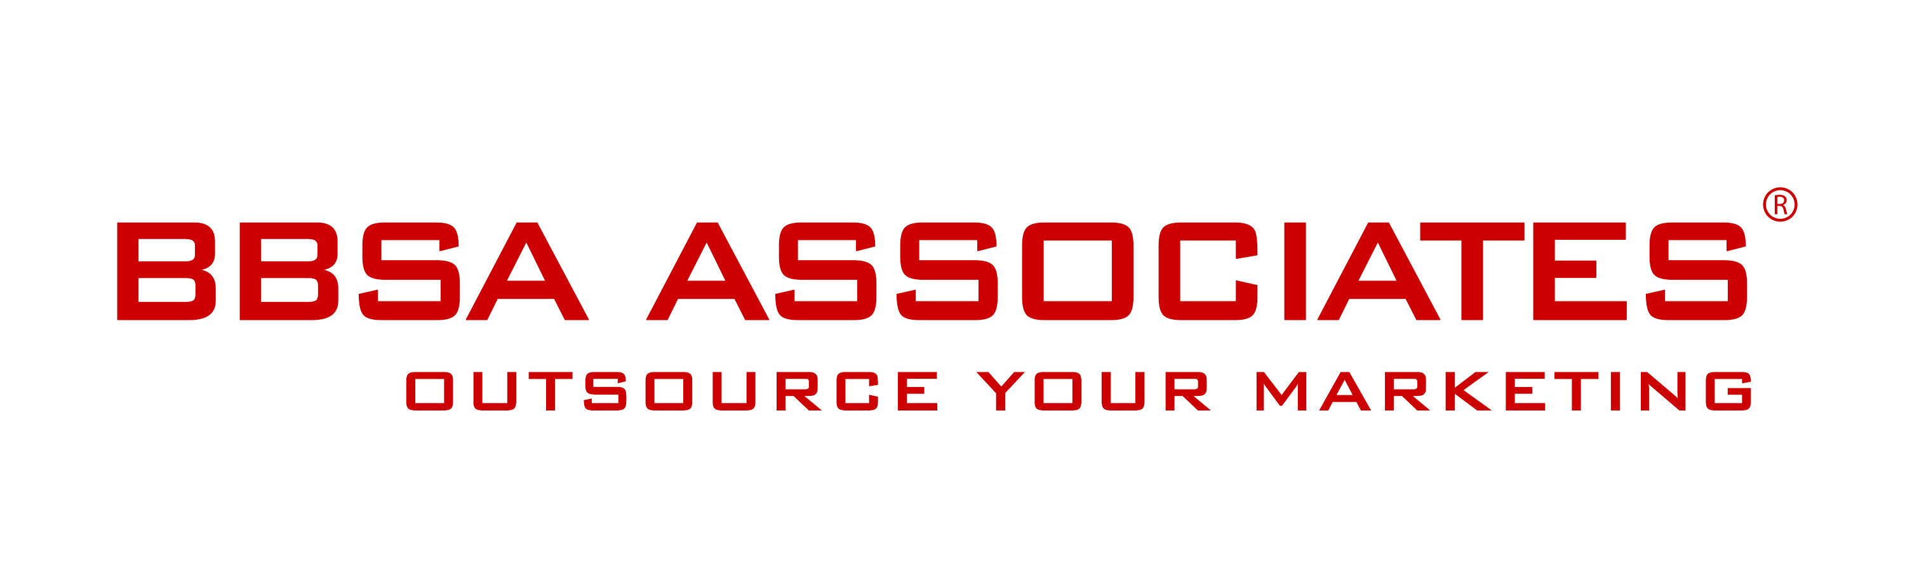

21 March 2017 -

Fuel The Change Initiative Discussed In The House of Commons
London, March 2017 - Multi award-winning energy and telecommunication consultancy MAXIMeyes, Baroness Verma, and Paul Scully MP are hosting the Fuel The Change reception in the House of Commons on 21/03/2017 to discuss how businesses can support the fight to tackle fuel poverty in the UK.
Almost 15% of households in the UK suffer from fuel poverty; the Fuel the Change initiative aims to lift a minimum of 1,000 homes out of fuel poverty by 2020.
The initiative, launched in November 2016, was discussed last week during the Adjournment debate in the House of Commons and welcomed by Jesse Norman the Business, Energy and Industrial Strategy Minister and Paul Scully MP. See House of Commons footage.
Paul Scully comments: “I am delighted to be hosting a parliamentary reception alongside MAXIMeyes and their excellent ‘Fuel the Change’ campaign. Fuel poverty is a real problem for a small but significant number of my constituents and others across the country. As a former businessman myself I fully endorse the innovative, business led approach adopted by MAXIMeyes to tackling this issue. Businesses can and should be a force for social good. Profit and social responsibility does not have to be mutually exclusive. I believe that in conjunction with action taken by this government ‘Fuel the Change’ can be a big part of the solution to this stubborn problem.”
The Fuel The Change reception will be hosted in the House of Commons - MacMillan Room - on 21/03/2017 from 1-3pm.
To find out more about the Fuel The Change initiative visit the website here. To join please contact our Fuel The Change Team on 020 8652 7525 or by email.
--- end of Press Release ---

Contact:
Anna Stella
BBSA Associates
207 Regent Street – 3rd Floor
Mobile: 07515122555
Phone: 020 7193 4298
Email: as@bbsa-marketing.com
Web: www.bbsa-marketing.com

- end of press release -

MAXIMeyes is an award-winning energy and telecommunication consultancy that provides tailor-made utility solutions. For more information please visit our website or contact our team on 020 8652 7525 or by email.

