Press Release
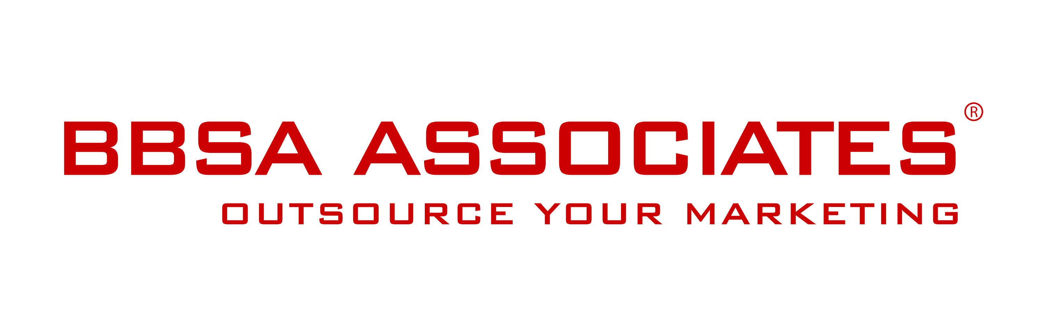

24 October 2014 -

BBSA Associates appointed as Growth Voucher Marketing Adviser

London, UK – October 2014 — Outsourced marketing agency BBSA Associates is proud to have been appointed as a Marketing Adviser in partnership with the Enterprise Nation Marketplace, part of the government's £30m Growth Voucher Programme.
Over the next few months the Growth Voucher programme will distribute vouchers to around £20,000 small businesses in England, in order to support their strategic activities including marketing growth and to help them attract and keep customers.
BBSA will advise these small businesses as recipients of the voucher, helping them to grow through strategic marketing consultancy.
Reacting to the announcement, Anna Stella said: “We are proud to have been selected as one of the marketing advisers to the Growth Voucher initiative. Small and medium sized businesses are the backbone of our economy and we truly believe that this government initiative can really help them to grow. We are a pioneer of outsourced marketing and we are here to help small businesses establish themselves through excellent marketing".
Founded in 2012, BBSA Associates is a full service marketing agency that provides support to small, medium sized and start-up companies and is a pioneer of outsourcing marketing.
- end of press release -

Contact:
Anna Stella
BBSA Associates
207 Regent Street – 3rd Floor
Mobile: 07400 904490
Phone: 020 7193 4257
Email: as@bbsa-marketing.com
Web: www.bbsa-marketing.com

BBSA Associates is a full service marketing agency. We provide marketing support to medium, small sized and start-up companies that are keen to move forward and develop their marketing activities but lack the time or know-how to do it themselves. We support a wide range of B2B and B2C companies across the whole spectrum of strategic and tactical marketing and communications; from helping out with a single solution for projects, to enabling you to manage your own 'outsourced marketing department'. See more

BBSA is a registered company and trademark in the United Kingdom.

Growth Voucher Programme: more information about the Growth Voucher initiative can be found Gov.uk or Enterprise Nation.

