Press Release
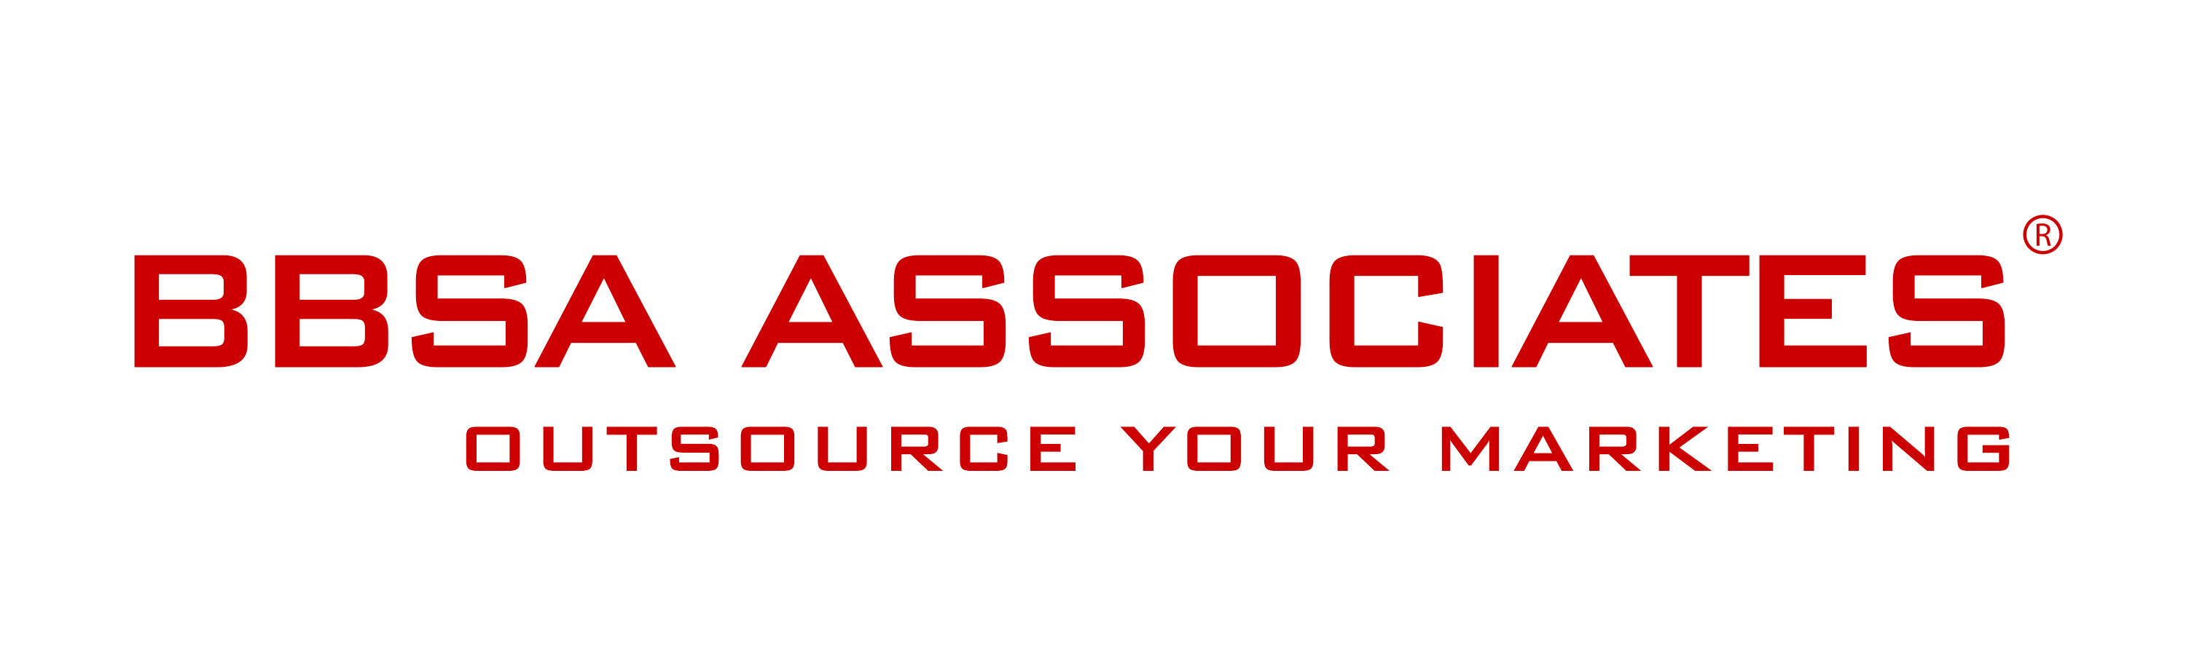

17 September 2015 -

European Country Inn Chef Contest to crown the emerging talent Italian chef in London

London, UK – On 27th September twelve Italian chefs will show their talent and creative skills and endeavour to win the European Country Inn Chef Contest.

The contest, sponsored by EEIG ECN, will take place at the cookery studios ‘Aveqia’ in central London.

During the day, the chefs will submit their signature dishes using the authentic, renown, ingredients from the LAGs territories of the three Italian regions Abruzzo, Campania and Puglia.
A select panel of judges lead by Italian celebrity chef Aldo Zilli will determine the London Italian emerging talent Chef. The winner will receive the European Country Inn Chef Award as well as a trip to visit the region and sample the prestigious food from the LAGs territories.

The European Country Inn Chef Contest is the third event in a series of events aimed at the promotion of European and Italian rural food specialities and establishments.

Contact:
Anna Stella
BBSA Associates
207 Regent Street – 3rd Floor
Mobile: 07400 904490
Phone: 020 7193 4257
Email: as@bbsa-marketing.com
Web: bbsa-marketing.com

EEIG ECN exists to promote tourism development in rural European areas as well as helping the public discover the social and cultural traditions of the rural food specialities and establishments.
The key values of the initiative is to promote:
- Food as Culture: to convey, enhance and promote the symbols and cultural patterns of the European rural areas
- Community creation: to create a sense of identity and pride of belonging in both the local citizens of the rural aggregate and the rural population around models of leisure
- Welcome visitors and consumers in a rural life setting, according to the local traditions
- Taste rural specialties: tours enabling visitors to discover the great products from these regions
- The local rural tourism.

BBSA Associates is a full service marketing agency that provides marketing support to medium, small sized and start-up companies that are keen to move forward and develop their marketing activities but lack the time or know-how to do it themselves. BBSA supports a wide range of B2B and B2C companies across the whole spectrum of strategic and tactical marketing and communications. See more
BBSA is a registered company and trademark in the United Kingdom.

Britaly Ltd exists to support and advise Italian small and medium sized food and wine producers seeking to export their products to the United Kingdom. Contact Roberta Almatelli for more information.

