Press Release
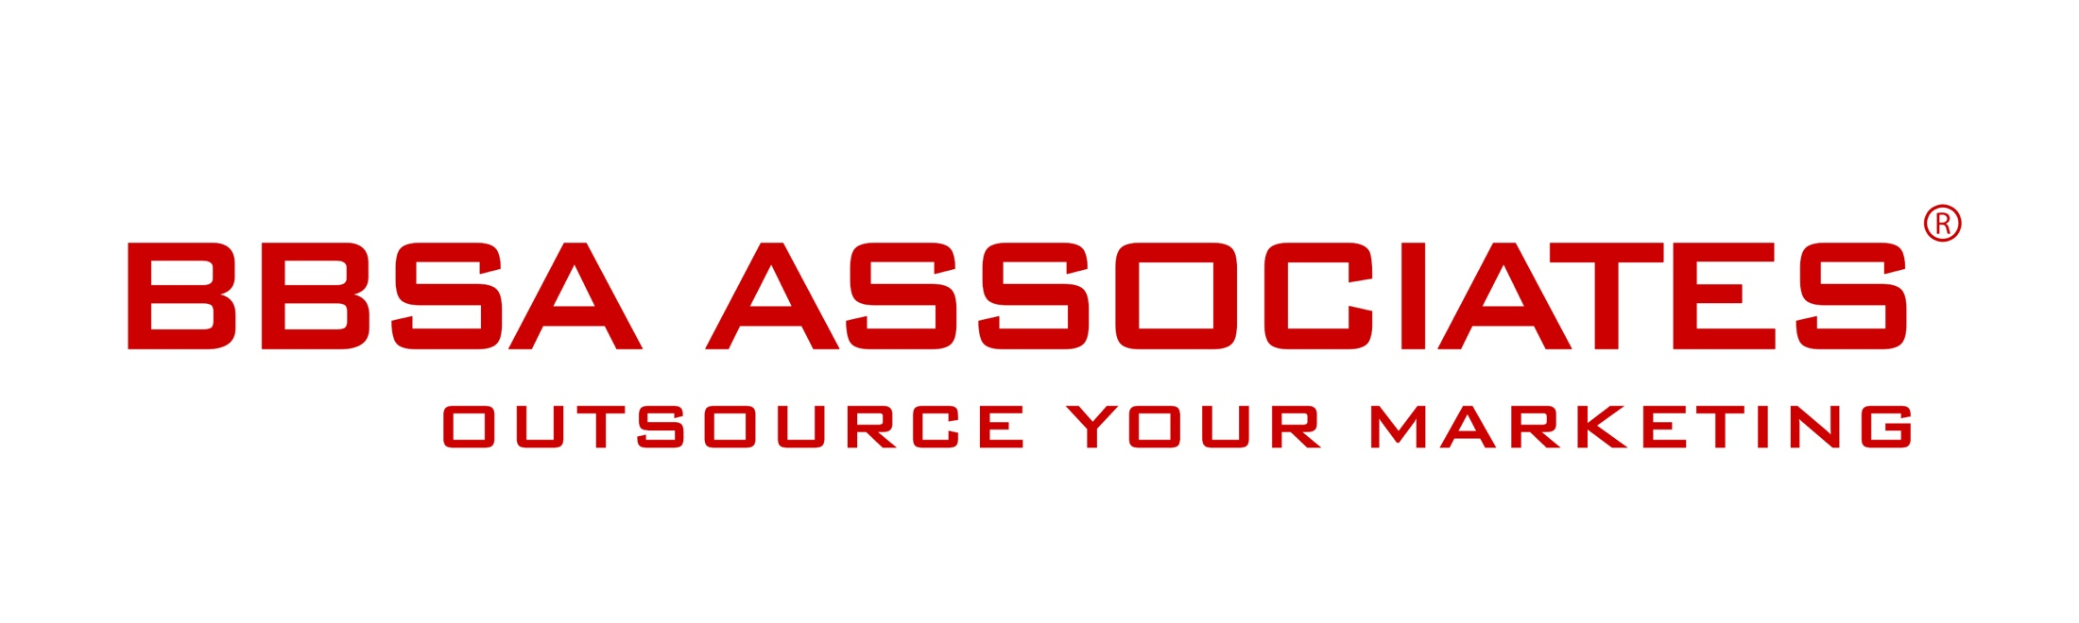

27 November 2015 -

Crowdfunding a smart product: Elephant High Chair designed to inspire children

London, UK – 27 November - Alex Swain unveiled a crowdfunding campaign for HABITAN, his innovative design for a new elephant-shaped high chair. The Born.com crowd funding campaign begins Nov. 27 and will last one month. The design draws on top innovations in both high chair functioning and child development. The emphasis is on inspiration, getting children interested in meal time. It is made to look good, is portable and supports proper posture. Strength, cleanliness and stability were key targets for the London-based designer, a recent father.

British and American safety standards were followed for the Habitan, a product whose name means Elephant Forest in the Nepali language. This product has a story, its name is inspired by the designer’s late brother who enjoyed riding elephants while growing up in Katmandhu. Sourced with sustainable materials and packed with features, the elephant high chair comes with facial expression stickers children to choose. Alex aims to raise enough early bird funds to manufacture the first 100 orders, to be delivered in April (€99 per unit on Born.com before it retails at £165).

The chair and campaign were created to redefine a new type of high chair, an object that can “turn meal times into a fun adventure; a stimulation of the senses to promote social development.” See the campaign

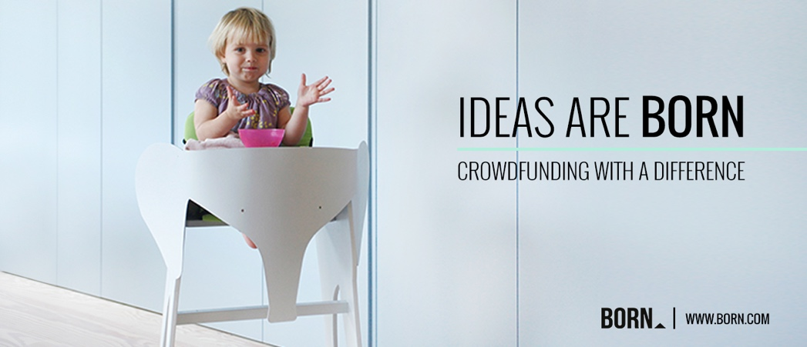

Contact:
Anna Stella - BBSA Associates
207 Regent Street – 3rd Floor – London United Kingdom
M: 07400 904490 I P: 020 7193 4257
E:as@bbsa-marketing.com I W: www.bbsa-marketing.com
- end of press release –

Alex Swain is the designer behind ByALEX. Based in London Alex creates bold, graphic products for the home and beyond. Driven by a conviction that designers should use resources wisely, Alex uses cutting edge technology to reduce waste and maximise efficiency. All the products are made in UK and Northern Europe using FSC/PEFC certified timber, sourced from responsibly managed forests. Alex designs products that have a genuine story, a reason for being. Products with the purest form and affordably priced. See the website
BORN is a crowdfunding platform with a difference. We are focused on projects that are invention and inspiration in design and for those projects that our design experts choose to feature on our platform, we offer the full weight of our extensive resources and support to assist you in making your dreams becoming a reality. BORN.com

