Press Release
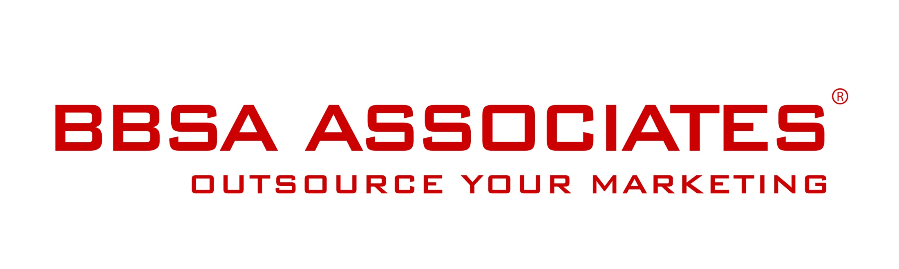

19 November 2015 -

TV Personality Nancy Dell’Olio launches Limonbello a brand new drink inspired by limoncello

London, UK – November 2015 — TV Personality Nancy Dell’Olio launches Limonbello, the new dinner drink inspired by limoncello. Nancy, who is a native Italian with a passion for food and having been inspired by her parents’ New York restaurant chain, has spent the past few years working on her own version of limoncello and she now wants to share it with the world.
Nancy brings limoncello back to life with her own improved twist of real green lemons combined with an acid-free and sugar-free mix. This organic Limonbello is set to become the Limoncello of Liminocellos, bringing a beautifully created fresh drink to the market. Limonbello is not only enjoyable in its own right but mixes well in cocktails and helps to create a versatile base for a range of sophisticated libations.
Nancy has chosen the designer-only crowdfunding platform BORN.com to launch Limonbello. As the first star to use a crowdfund reward platform to launch a product, Nancy sets a new standard showing how crowdfunding has become mainstream.
Nancy is seeking to reach her goal of raising £70,000 to start producing Limonbello. Link to her campaign page.
Contact:
Anna Stella - BBSA Associates
207 Regent Street – 3rd Floor – London United Kingdom
M: 07400 904490 I P: 020 7193 4257
E: as@bbsa-marketing.com I W: www.bbsa-marketing.com
- end of press release -

Nancy Dell’Olio a lawyer and businesswoman as well as an ambassador for many worthy causes, Nancy enjoys a degree of celebrity, which she has dedicated to launching authentic products from her home country as well as supporting initiatives in sustainability and women’s issues and leadership. Link to her campaign page.
BORN is a crowdfunding platform with a difference. We are focused on projects that are invention and inspiration in design and for those projects that our design experts choose to feature on our platform, we offer the full weight of our extensive resources and support to assist you in making your dreams becoming a reality. BORN.com
BBSA Associates is a full service marketing agency. We provide marketing support to medium, small sized and start-up companies that are keen to move forward and develop their marketing activities but lack the time or know-how to do it themselves. We support a wide range of B2B and B2C companies across the whole spectrum of strategic and tactical marketing and communications; from helping out with a single solution for projects, to enabling you to manage your own 'outsourced marketing department'. See more

BBSA is a registered company and trademark in the United Kingdom.

