Press Release
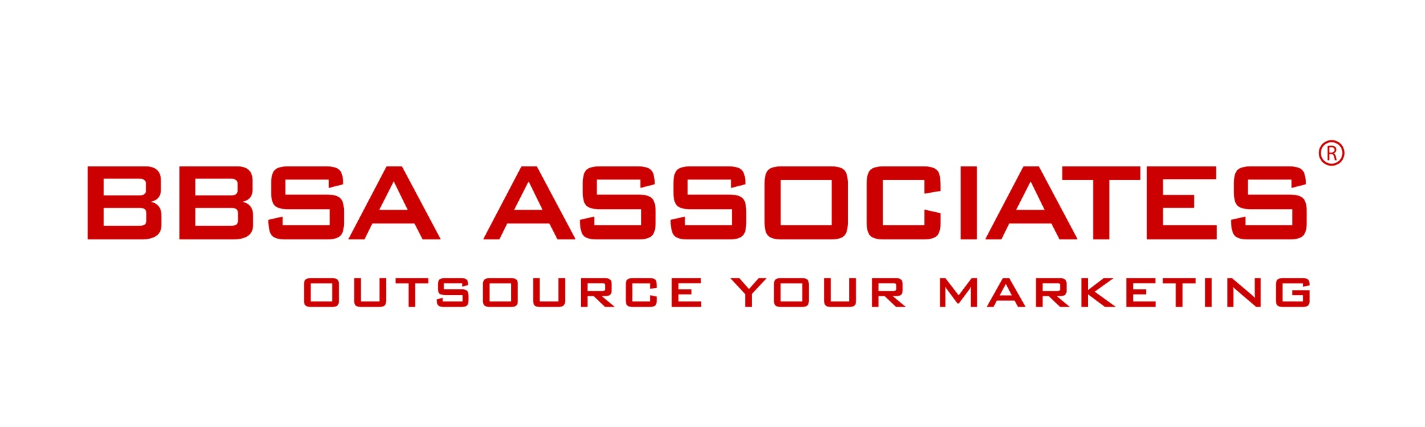

5 January 2016 -

Nancy Dell’Olio Enters The Celebrity Big Brother House After The Launch Of Her Drink Limonbello

London, UK – January 2016 — TV Personality Nancy Dell’Olio enters the Celebrity Big Brother House tonight. Nancy has launched a crowdfunding campaign to raise funds from the public to produce Limonbello, her new version of limoncello last month.
Nancy who is a native Italian, has a passion for food inspired by her parents’ New York restaurant chain. She has spent the past few years working on Limonbello, her own version of limoncello, and now she wants to share it with the world. Encouraged after tinkering with real green lemons and her family’s ingredients, Nancy’s new drink Limonbello has a new twist on the traditional libation, starting a line of premium brand drinks.
To launch Limonbello a crowd platform will be used to sell pre-ordered bottles and other rewards. This will give consumers the chance to taste the drink and purchase packages with Nancy.

Crowdfunding Opportunity
- Offers a £4 voucher to enter a prize draw to spend a full day with Nancy in London
- One bottle of Limonbello to pre-order for £25, two bottles of Limonbello to pre-order for £45 and six bottles for £140. All prices are in Euro in the campaign page.
- Crowdfund available at https://www.born.com/view/799/limonbello-
until Feb 2016.

WHAT MAKES LIMONBELLO UNIQUE?
- Authentic yet healthier recipe of low alkaline constitution by comparison to most alcoholic beverages, which are generally highly acidic.
- The process contains only natural products and no added sugar or artificial sweeteners.
- Limonbello is both organic and strong in alcohol content.
- Mixes well with other drinks in cocktail form or on its own. Enjoy it on the rocks.
- Appealing to both discerning men and women looking for something fresh to complement their meal, or just to savour as a standalone refreshment.
Nancy is seeking to reach her goal of raising £50,000 to start producing Limonbello.. Link to her campaign page.
Contact:
Anna Stella - BBSA Associates
207 Regent Street – 3rd Floor – London United Kingdom
M: 07515 122555 I P: 020 7193 4257
E: as@bbsa-marketing.com I W: www.bbsa-marketing.com
- end of press release -

Nancy Dell’Olio a lawyer and businesswoman as well as an ambassador for many worthy causes, Nancy enjoys a degree of celebrity, which she has dedicated to launching authentic products from her home country as well as supporting initiatives in sustainability and women’s issues and leadership. Link to her campaign page.
BBSA Associates is a full service marketing agency. We provide marketing support to medium, small sized and start-up companies that are keen to move forward and develop their marketing activities but lack the time or know-how to do it themselves. We support a wide range of B2B and B2C companies across the whole spectrum of strategic and tactical marketing and communications; from helping out with a single solution for projects, to enabling you to manage your own 'outsourced marketing department'. See more

BBSA is a registered company and trademark in the United Kingdom.

